

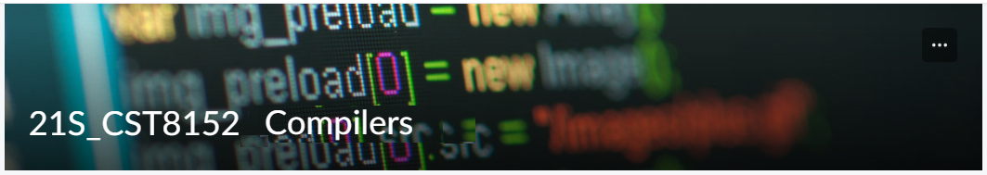

MODEL TASK FOR ASSIGNMENT 2.1 – Vision

Shivam Patel- Id: 0410434323

PART 1: RE – Regular Expression (1.5 mark)
Lexeme Classes: Define the classes to be used in your regular expression:
Lexeme Classes: W = [A-Z]
L = [a-z]
D = [0-9]
S = [+|-]
C = [# | #* | *#]
M = [:]
P = [.]
Q = [ ‘| “]
O = [\n]
E = [e]
U = [ _ ]
F = [^WLDU]

Define the RE to be used for: variables, literals and keywords:
Answer:

* Variables: L[W|L|D|U]⁺

* Integer Literals: [S]?D[D]*

* Float Literals: [S]?D[D*]?PD[D*]?[[E?]D*]?

* String Literals: Q[W|L|D|S|C|P|O|U|F]*

* Keywords: L[W|L|D|U]⁺

* Multi-line comment: C[W|L|DS|M|P|Q|O|E|U]*C

PART 2: TD – Transition Diagram (1.5 marks)

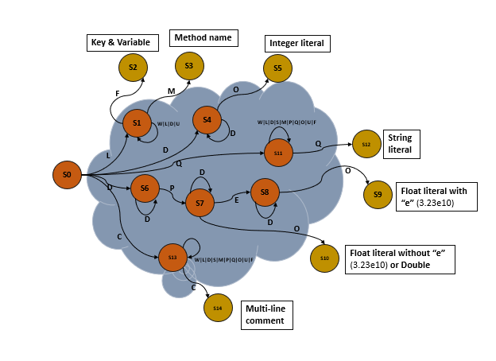

PART 3: TT – Transition Table (2 marks)

Activity: Now, it is possible to define the TT for these lexemes:
S/E | L | D | S | C | M | P | Q | O | E | U | F
S0 | S1 | S4, S6 | S15 | S13 | S15 | S15 | S11 | S15 | S15 | S15 | S15
S1 | S15 | S1 | S15 | S15 | S3 | S15 | S15 | S15 | S15 | S15 | S2
S2 | FS | FS | FS | FS | FS | FS | FS | FS | FS | FS | FS
S3 | FS | FS | FS | FS | FS | FS | FS | FS | FS | FS | FS
S4 | S15 | S4 | S15 | S15 | S15 | S15 | S15 | S5 | S15 | S15 | S15
S5 | FS | FS | FS | FS | FS | FS | FS | FS | FS | FS | FS
S6 | S15 | S6 | S15 | S15 | S15 | S7 | S15 | S15 | S15 | S15 | S15
S7 | S15 | S7 | S15 | S15 | S15 | S15 | S15 | S10 | S8 | S15 | S15
S8 | S15 | S8 | S15 | S15 | S15 | S15 | S15 | S9 | S15 | S15 | S15
S9 | FS | FS | FS | FS | FS | FS | FS | FS | FS | FS | FS
S10 | FS | FS | FS | FS | FS | FS | FS | FS | FS | FS | FS
S11 | S11 | S11 | S11 | S11 | S11 | S11 | S12 | S11 | S15 | S11 | S11
S12 | FS | FS | FS | FS | FS | FS | FS | FS | FS | FS | FS
S13 | S13 | S13 | S13 | S13, S14 | S13 | S13 | S13 | S13 | S15 | S13 | S11
S14 | FS | FS | FS | FS | FS | FS | FS | FS | FS | FS | FS
*S15 | ES | ES | ES | ES | ES | ES | ES | ES | ES | ES | ES

*S15 is error stage.

